**Chapter 22 – FIRST MOVE TO ARIZONA AT 235 W Hunter in Mesa – June 1971 to July 1973**

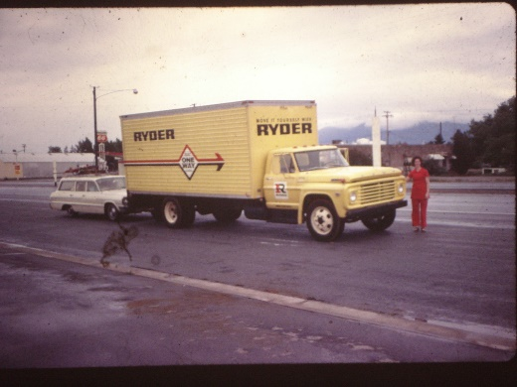I flew down one weekend to look at homes with Ken. We found one in the Lehi area and bought it. It took a couple of months for the loan to go through so **we rented an apartment close to Larry & Tammy**. The apartment was very nice and it had a pool. Ken & I drove down with the moving truck and unloaded it. They were supposed to have the power on, but they didn't, so we spent the night at Larry & Tammy's and I flew back home to get the children and Ken went to work. The children had stayed with Mom & Dad while Ken & I took the truck down. When Ken met us at the airport that night, he didn't look so good. As we drove to our apartment, he told me that **the apartment had caught on fire and burned a lot of our stuff**. I was sick. The insurance adjustors wouldn't let us in the apartment and so we again stayed with Larry & Tammy. They were always gracious and hospitable. The owners of the apartment helped us move into another apartment and we did salvage most of our things. I had to take the clothes to the Laundromat or the cleaners to get the smoke out. A lot of the things we had in the kitchen were burned up. The men Ken worked with all chipped in and gave us money to replace a lot of it. They were neat. Larry & Tammy also gave us some things they didn't need. I guess the things I missed the most were my recipes. They had burned.

The landlords let us move into another apartment and we liked it there. Sometime later, we received a letter from the insurance company saying they were suing both the power company and Ken & I. I couldn't believe it, why would they sue us. Well, I have since learned that insurance companies go after anyone they can find that might be responsible - so they can get their money back (what a gipe - we pay tons of money to all different insurance companies, auto, life, home owners, health & accident, etc., and they still go after anyone they can to reclaim the money they put out. It makes me mad) They claimed that we set our boxes on the stove when we moved into the apartment, and when the power company turned on the power, the stove was on (left on by the cleaning lady, they think) and it burned the boxes and started the fire. We didn't put boxes on the stove, but on the cupboard by the stove, and since it got so hot, it did ignite the boxes and the fire went fast after that.

Our stake executive secretary was a lawyer, so we went to him about it since the insurance company had sent us a deposition to fill out. We asked this lawyer how much chance we would have if we tried to fight it ourselves. He said practically none. We asked how much chance we had if we hired him. He said about a 50% chance. He charged $40 an hour and that was in 1970. We didn't know how we would pay the money, but sure didn't want to lose the lawsuit. I think the amount we would have had to pay if we lost was $5,000 plus court costs, etc. $5,000 was really a lot of money back then also. We had filled out the deposition and he changed everything but our names. He told us that we didn't know for sure how the fire started. We just took the insurance company's word for it - we were not there when it started. He said if we left it the way we answered it, they would be able to sue us. But if he changed it and said "we don't know", the insurance company would have to prove what happened. Well, it went on and on and we were pretty worried, but our lawyer ended up winning in our behalf - so we were grateful we had hired him. Even though it cost us a few hundred dollars, it was better than a few thousand dollars. It is still so unfair that the victim gets this kind of treatment.

We did have fun those couple of months in the apartment. The children and I would swim a lot of the time during the day and at night when Ken was home, we would swim again. Sandi got "swimmers’ ear" and had to have medication for it. Ken & I and Larry & Tammy would get the younger children in bed and let the older girls babysit while the four of us would go for walks. It was so beautiful in that area. I especially loved the palm trees. There was an ice cream place between close to where we lived. They had a popsicle type treat which we all loved and we got those quite a lot.

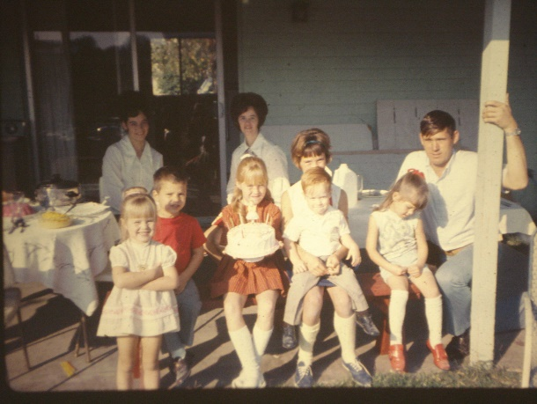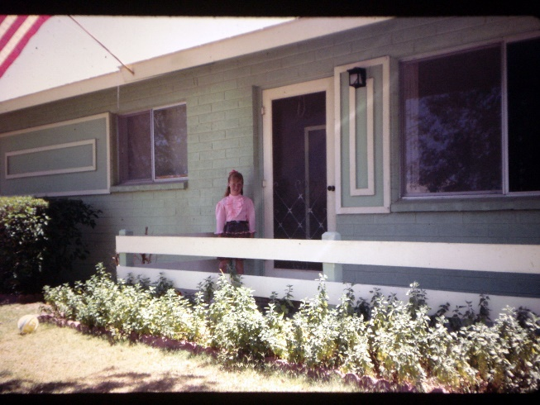We moved into **our home at 233 West Hunter** before school started and liked the home, yard, neighborhood and ward. The front yard had a small white picket fence. It was hard to keep the grass clipped and it looking nice, but I always worked at it as I like a neat yard. Every week or more often if needed, I would get my little lawn sheers out and cut the grass from around the fence. It was quite a job, but it looked so nice after it was done. I have always enjoyed yard work, but Ken hasn’t. Good thing one of us did or our yards wouldn’t have looked very good. It also had two large trees in the front yard. I remember hearing terrible loud noises at one time of the year. It was the locus. These were huge beetles and they liked our trees. They made so much noise it about drove me crazy. Thank goodness they were not there all year long. Sometimes they would get on the screen doors and when we opened the door, they would fly in. I hated them as they would fly at you. I liked our backyard. We had a covered patio the length of our house. We put our washer and dryer out there and a picnic table, etc. We enjoyed it out there. We also had lots of roses. We had a hedge of small red roses all around the back yard, plus a beautiful peace rose growing up the clothes line pole and one on a trellis by the carport. The one on the clothes line had beautiful, large pink and yellow roses. Each rose was different. Some were almost all yellow with a little pink and some were almost all pink with a little yellow and many were somewhere in between. I loved that rose bush. We had both orange and grapefruit trees and enjoyed the fruit from these trees. We planted a garden and found that to be very different from our gardens in Utah. We didn't plant much during the summer as it was too hot and would burn the plants, but we had lots of vegetables all during the fall, winter and spring. Shellie really loved spinach so we planted that too. I also used the spinach in green salads.

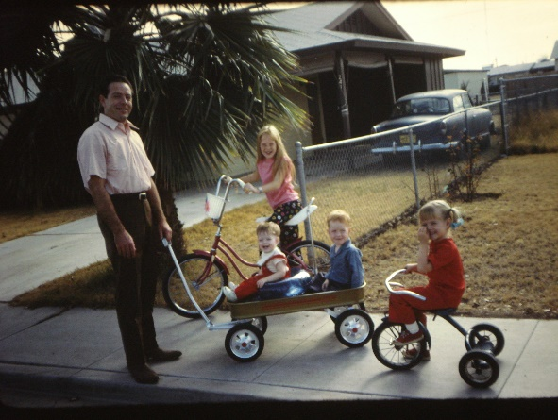 I liked our covered patio also. It went the length of the house. The children played out there all year long. We had our washer and dryer out there also, as there wasn’t room in the house. Ken made the children a cute set of cupboard and stove and they had fun playing with it. I remember Sandy and Lori (Tammy & Larry’s oldest daughter) getting together and making up plays. They would make costumes out of blankets, old clothes, cardboard, etc., and involve the other children. When they had it ready, they would have Larry & Tammy & Ken & I come out and watch it. They were very creative, and they were cute.

Sandy is in the 4th grade. Shellie is 4, Mike is 2 and David 11 months. We sure enjoy our little family and feel we are really blessed.

**We also had many wonderful neighbors. The Premacks especially**. We met the Premacks through their daughter, LuAnn, who became Sandy’s best friend. They moved here from Oregon where he had retired from the service. He got a job in the telephone company in Mesa. They bought a new home on Freeman. We were at the time living on Hunter. Sandy and LuAnn had much in common and enjoyed being together. I went over to meet LuAnn’s mother and welcome them into the neighborhood. Both her and her husband were very friendly and wonderful people. We started fellowshipping them as they didn’t belong to any religion. We became good friends. One day Sandy came home and said that if we didn’t ask the Premacks the golden questions (“what do you know about the Mormon Church, and would you like to know more?”) that she was afraid that they would join the Methodist Church as a lady that Mrs. Premack (Joan) worked with had been getting her interested in that religion. Immediately we went over to visit with them and asked them these questions. Mr. Premack said “Yes, he would.” Joan hesitated, but finally said yes. We though we explained to them that we would have the missionaries come and explain the gospel to them if they came to our home the following Sunday night, but they didn’t understand it that way. They thought we were going to explain it to them. They came that night, but when they saw the missionaries, they became cold. Especially Joan. When they left after the presentation, they accepted a Book of Mormon, but we were afraid that it wouldn’t go any further. Hal Premack read and enjoyed the Book of Mormon, but Joan wouldn’t. So, they joined the Methodist Church. We felt bad and disappointed, but it didn’t stop our friendship with them. We moved on Freeman into our new home and became their neighbors. They lived two houses down from us. We visited with them several times and went places together. When we moved to Utah, they still wrote for a while. Sandy sure hated to move and leave LuAnn because they were such good friends. So far (1977) she still hasn’t found as close a friend as LuAnn was, and she still misses her although she is happy here on the farm.

Soon after we had moved in, the Bishopric from our ward came to visit us. They asked me to accept the position of **Laurel teacher**. I was excited as I loved the young women and had been in the MIA program most of the time we lived in Ogden. I had thought the Laurels would be the best class to teach, but that wasn't the case in this ward. They were boy crazy, disrespectful to me and each other (actually everyone), rude, etc., etc. I remember the first time I went to teach them. Again, this was before the block system and we had MIA on Tuesday nights. I sat in opening exercises with these girls and watched them make fun of a younger girl - a Mia Maid, whose father was the counselor in the bishopric who called me. They had 14 children. They were a wonderful family, but didn't have a lot of money because it took a lot to feed and clothe that many children. These Laurel girls, especially one, **Sharla Allen**, really gave this girl a hard time. Sharla would say with a sarcastic tone "mice are running all over you - in your hair, down your back, everywhere" and would laugh. I didn't take very much of it when I told Sharla to stop - that it was awful of her to do that to this girl. She gave me a dirty look, but did stop. In class the 8 girls were terrible. One was combing another's hair, two were talking about the dates they had the previous night and laughing, another was doing school homework, etc., etc. They were definitely not listening to the lesson and I had taken a lot of time to prepare. I came home crying and very upset. It went on like this for some time. We had an activity with the boys where we were to teach them to make cookies and how to iron a shirt (so these things would help them on their missions). The boys were to teach us how to change a tire, check the oil in the car, etc. This activity turned out to be a disaster. One girl, Kathy Westbrook, one of my greatest trials even was lighting matches and flicking them at other kids. We got that stopped, but the entire evening was awful. I was very discouraged when I went home. All the activities turned out a disaster the first six months. I tried many different approaches and finally after I decided to fast and pray each week before going to M.I.A., I was finally able to make some progress. For our service project we decided to make cookies, candy and popcorn balls and send to the missionaries and service men from our ward. We did this in November. We made them at my home; afterwards we had banana splits or Sundays. I made special favors for the girls with cards of appreciation to them. This really helped their attitude towards me and from then on, they showed love and respect and listened and participated in the lessons.

Ken had the same girls and also the guys their age in his Sunday School class. He is a good teacher and usually doesn't have any trouble with classes he has taught. He can also step in at the last minute when a teacher hasn't shown up and he does great. But, this class was so awful that he finally quit. That's the first time I have seen him quit a church calling. He said the final straw was when he saw a guy and girl petting right in class. Their parents were leaders in the ward. He got so angry, he walked out of the class and told the Sunday School president that he was not going to waste his time babysitting this group of youth. Perhaps I would have quit had that happened to me, but I did have a miserable 6 months. I came home crying more than once. I learned to love those girls and really enjoyed them for the remaining six months. Their names were: Debbie Opie, Kathy Westbrook, Mechille Pomeroy, Sharla Allen, Janice Cooley, Chery ? (can’t remember the other’s names). Kathy Westbrook, my main problem girl, got married soon after graduating from high school. I went to her reception. After moving back to Utah, a few months later, we were invited to come to the Salt Lake Temple and see Debbie Opie married and afterwards to her wedding breakfast. It was really nice and I was proud of Debbie that she married in the temple. She met him at B.Y.U. He lived in Salt Lake. Debbie was the president of our class. Her dad was a counselor in the Bishopric. Now he is Bishop. He told Ken that if we’d still been living down there, he would have had him for a counselor.

The one girl, Sharla Allen got married and had a couple of children and when our family moved down to Arizona the second time and moved into the Mesa 42nd ward, **Sharla, her husband** and their family were in that ward. **They called me to be the primary president a short while after we were there and I called her to be my counselor**. She was a great counselor and it was a wonderful experience serving with her.

In August, after teaching the Laurels, Helen Freeman, the president of the primary asked for me to be her counselor over the girl’s program and the targeteers. Her other counselor was Kathy Trendler, the secretary was Norma Powers. I enjoyed working with these women very much, also my teachers. They were terrific. I loved Helen. We became good friends. She wasn't as organized as I wished, but a great president non-the-less. Kathy moved and Helen called Laraine Aldredge to be her new counselor. She was a very sweet lady. We worked well together. I enjoyed the primary children and working in this presidency.

Helen had a cow and sold milk so we bought milk from her. We have always been health conscious and felt that whole milk was much better for us than pasteurized milk, so always tried to find someone with a cow (if we didn't have one) and buy milk from them. My parents were always health conscious, especially dad, and so I grew up this way and wanted my family to be healthy too. Mom always had a garden and I helped weed and care for it and helped her bottle bushels of fruit and vegetables every summer and fall. Even at age 81, she still wanted to bottle soup, relish and peaches, even though her cupboards and fruit shelves are full.

Sandy was a Merrie Miss so she was glad I was over the girls. The only bad thing was that with me being over the program, I knew all about the daddy-daughter parties and Mom & Miss parties. I would have to conduct and see everything went smoothly so it was hard to be right with Sandy and make it special for her. She was disappointed that she couldn’t surprise me about the projects because I had to help plan them. Our presidency meetings were both fun as well as constructive as we’d laugh and joke with each other and enjoy being together. I was in this position for two years until we moved the end of May, 1974. I felt it was a wonderful and successful two years. My teachers were Margie Owens - Merrie Miss A and Lois Porter - Merrie Miss B and Darlene Smith - Merrie Miss B. The Targeteer teachers changed several times, so I can’t remember all their names. Lois and I were already good friends and the two of us and our husbands would get together a lot to play games, eat, etc.

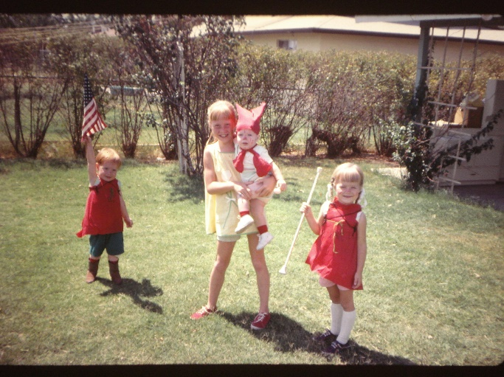

**UPDATE ON CHILDREN - ARIZONA**

**Sandy** was 10 and 11 when we lived in this home. She was a sweet and obedient daughter. She was such a great “big sister”. She would play dolls with Shellie, Mike & David, play school with them with her being the teacher, make up plays & make costumes for them. Her and her friend, Lori, would many times do this when Larry, Tammy were visiting us or we were at their home

**Shellie** was such a cute little daughter. She was so good that sometimes I didn’t give her the attention she deserved. Ken remembers how she was so stubborn and strong willed when she was growing up. I don’t remember her being that stubborn and strong willed. I know she was and usually that was good. They say that we should pray that our children will be strong willed so they can resist the evil temptations of this world. Most of the time, Shellie was a happy, contented child - content to play with friends, siblings or by herself. I remember one day that she came to me and asked if I could make her a dress. I had made Sandy some clothes as she was older and guess I thought she needed them more than Shellie. I saw the yearning in her eyes - so I said “yes, and you can pick out the pattern and material”. She did and it turned out to be a really cute dress. She looked so cute in it and she was so proud of it, that it made me feel bad that I hadn’t thought of it myself.

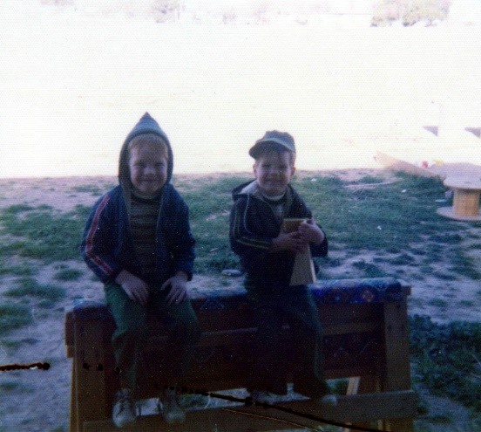

**Mike and David** were so cute too. They were best buddies from the time David was born. Oh, they had their disagreements and battles as all children do, but for the most part, they really enjoyed each other. Here in Arizona they didn’t need friends because they had each other. The first Christmas when we lived in our new home on Freeman, Ken build a sandbox for them. We bought them each a big Tonka truck, so that morning after we had opened our presents, they wanted to go outside to play in the alley behind our home with their trucks. It is nice weather in Arizona in December so we said “sure”. We were excited to see if they would notice the sandbox. Mike started out the door first and was heading right for the alley. David got out the door and spied the sandbox (it was in the far corner of our lot) and it got so excited and headed for it. He said “Mike, come over here”. When Mike turned around and saw David playing in the sandbox, he was really excited too and ran as fast as he could to it. They had lots of fun from then on playing in that sandbox. I’m sure Shellie and maybe Sandy played in it too. I remember Ken wrestling with the children. They were so noisy that I thought the roof would come off, but I loved it. I loved seeing Ken playing with the children and all of them having so much fun. I have the greatest husband and children in the world - at least as far as I’m concerned. I remember seeing David and Mike walking in Ken’s big shoes or boots. I remember seeing them riding around on their dad’s back as he gave them horsy rides. He wasn’t always a gentle pony, but a bucking bronco lots of times, and they loved it. Shellie and Sandy got rides too, at least Shellie.

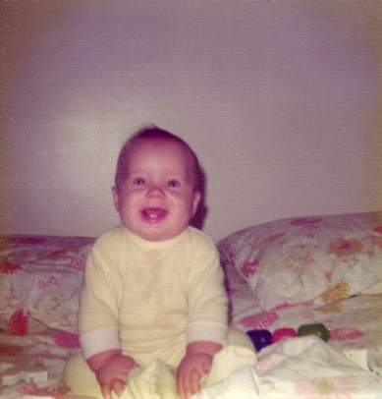**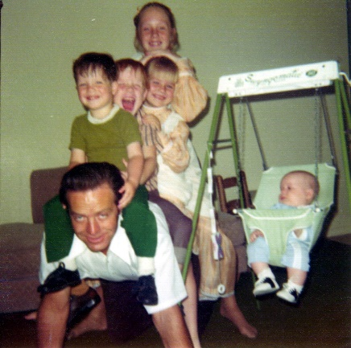Scott** was such a cute baby, and we enjoyed him so much. Ken’s parents and my parents came to visit and at night we would play Rummy and drink postom while dunking ginger snaps in it. I was doing this to help my milk come in more while I was nursing him. All of us enjoyed this. Ken was a good dad; he was always wrestling with them or giving them horseback rides, etc.

The past four years have been wonderful and eventful, but also, we’ve had trials and many decisions to make.

We enjoyed our home on Hunter, but the home was small so in October, 1973, we sold our home and bought a larger, newer home just a block and a half away at 1669 N Freeman. This was a nicer home in a better neighborhood. It was on a corner lot. We loved this home. You could either come in from the carport into the kitchen, or the other front door took you into the living room. A nice laundry/storage room was off the kitchen to the north and a large family room was adjoining the kitchen. It had 4 bedrooms and 2 baths, a nice size yard and a covered patio in back. The master bedroom & bathroom were really nice with special features.

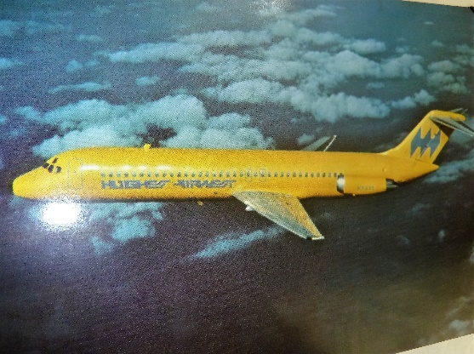 We had good benefits with **Hughes Airwest Airlines**. We could fly anywhere Air West flies for $4.00 round trip (just the cost of the service charge) We flew stand-by, but that hasn’t been a problem most of the time. We also got benefits with the other airlines. Also, Ken’s parents got this same benefit, but not my parents. Because of this low expense to fly, we seldom drove to our parents - or anywhere out of state, and we usually visited our parents at least once a month. It has been so great. I love to fly and so do the children. We flew over to visit Ken’s brother Roy and his family in Fresno, California also.

**Fresno, California to visit Roy & Linda**. We have only gone a couple of times. They took us to San Francisco one time and that was fun. The other time, Ken went fishing with Roy & Steve on a fish charter boat. It was stormy and both Roy & Steve & many others got sea sick, but Ken didn’t get sick because he had taken the sea sickness pills which were offered. They didn’t catch anything. Steve was a little boy and had been excited to go, but when he got sick, he kept saying “I don’t want to fish, I want to go home.”

Another wonderful trip was to **Washington D.C.**, while Ken was working for Hughes Air West Airlines**. Ken had a meeting with the Federal Aviation Board**. We left on a Friday. We flew to Chicago and from there to D.C. We enjoyed being together. We had reservations at a beautiful hotel. While Ken was in meetings the next morning, I went out among the beautiful gardens. There roses and so many different shrubs, trees, fountains - it was so beautiful. It was like a plantation (at least how I picture them). I wrote a talk which I was to give the following Sunday in Sacrament Meeting. The meeting wasn’t very long because the people, over it from DC, were not prepared. Ken was very prepared, and was the first one to complete the computer software for the Federal Aviation Committee – the Freight Cargo System. Anyway, that gave us more time to see the sites Ken returned about noon and we rode the bus to the White House and from there we walked to a cute café to eat lunch. We then walked to the Lincoln Memorial, next to the Washington Monument where we rode the elevator to the top and then Ken wanted to walk down the stairs. They wouldn’t allow you to walk up the stairs - as it was too steep and too many, but you could walk down. I didn’t particularly want to walk down them as we had been walking all over this area to see the sights, but Ken was persistent. He said he wanted to be able to say he had walked down the steps at the Washington Monument. I gave in, but about half way down, I wished I hadn’t. By the time we were at the bottom my legs, feet and whole body were very tired. Oh Well, we made it. We then went over to the Smithsonian Institute and to the Capital Building. By then it was starting to get dark. We had been warned that it wasn’t safe to be out after dark so we caught the next bus back to our hotel. We noticed as everyone was getting on the bus, that they were all black. As more and more got on, we began to get nervous. Even the bus driver was black, we were the only white people on the bus. We started praying silently for our safety and we did make it back to the hotel. We went across the street to a café to get us something to eat. It was a great day. The weather was beautiful and it was fun being together and being in this historic place. The next morning, we ate breakfast in the hotel and flew back home. I hated to see the time end. I loved every moment of it and sure enjoyed being with my wonderful husband

While Ken was working for Hughes AirWest Airlines, his manager was **Ron Shumway**. Ken really liked Ron. Ron was really fair with his employees. If he needed them to stay late or come early because of deadlines they had to meet, he would compensate them by having them take off early another day. Ken really liked Ron and felt Ron was a great manager. However, because of politics in business, Ron was changed to another department and they put a retired army Sergeant in as their manager. He expected way too much and wasn’t fair with them like Ron had been, so the moral went rock bottom. The Data Processing Department was about the only department in their airlines who wasn’t union. The men started talking about calling in the union, but no one dared to do it. Ken had an office where the others were out on the floor in cubicles - so they would come in and complain to him. Finally, he said “alright, I’ll call in the union if you are all for it and will stand behind me.” They all said they would, so he called. That was one of the biggest mistakes Ken has made. He loved his job with Hughes Air West and had really built a reputation for himself. He was very good at what he did and would fly over to San Francisco at least once a month to meet with the company people over there. Well, as you might suspect, the men didn’t stand behind Ken. Someone went to the big bosses and told them that the union had been called in. They sent out notices that if anyone went to the meeting, they would be fired. Of course, they couldn’t do that, but they frightened these employees into throwing away their cards and they didn’t attend. The big bosses started looking for the person who called the union. It would have only been a short time until they would have found Ken, so he quit his job. Other employees both at Phoenix and at San Francisco asked him what he was doing. They couldn’t believe he would do this when he had made such a name for himself in the company. When he explained what he did, they said “Well, it surely was nice knowing you Ken”. Ron had quit also as he was very unhappy the way the company had dealt with him.

**Hawaii in 1972 - Ken and Ron got to talking and said they wished they had taken their wives to Hawaii before they had quit,** and Ron said “Wait a minute, we can still do it as we have so much time before our paperwork is done.” He called and made the arrangements and he and Audrey and Ken & I flew to Hawaii and had a fantastic five days. **This was the last of April 1972**. We flew to San Francisco on Hughes Air West Airlines and from there went on an American 747. We enjoyed the flight over. We enjoyed being with Ron & Audrey. Since Ron & Audrey were neighbors, and in the ward with Larry & Tammy, they had become good friends. We all went camping together several times, motor cycle riding and going out to eat together.

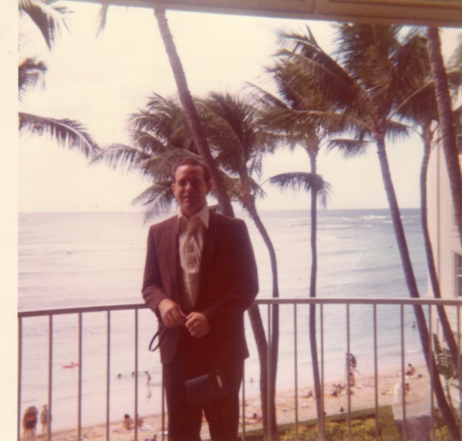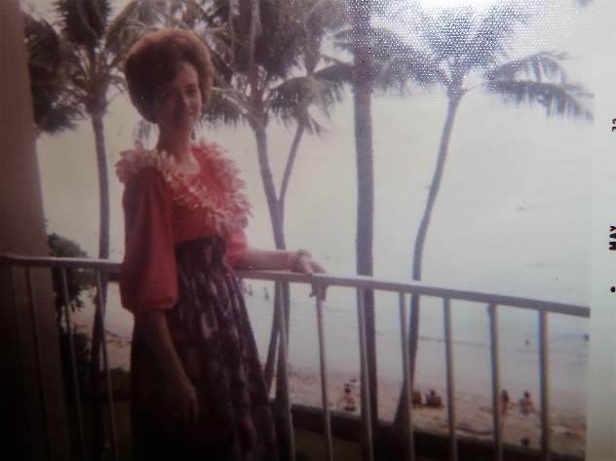We saw the movie “What’s Up Doc” on the flight over. We stayed in a beautiful hotel on the beach. That night we all walked along the beach enjoying the beauty. We had a balcony overlooking the ocean. At night in bed, I would watch the ships come in, watch the palm trees wave with the breeze and listen to the doves and the sounds of the ocean. I only slept maybe an hour or two each night because I was too excited and thrilled to be in Hawaii and I couldn’t stand to sleep and miss any of this beauty and wonder. This was the one special place in the world I’ve always wanted to go and never thought I’d get the chance to go there. The next day we rented a car and drove around the island. We bought pineapple at the pineapple fields. We saw the sugar cane, and banana trees, the beautiful ocean. We had lots of fun finding coconuts and trying to open them the way we’d been shown at the Pollyannaism village. That was a wonderful highlight going to the Pollyannaism Cultural Center. After going through the village and seeing all the different tribes and what they do, eat and their way of life, we paid $10.00 to see the show that night which was fantastic. The costumes, dances, songs, etc., were rally great. We also visited a place where there were beautiful flowers, trees, etc., as we walked along a path. Then inside the building were lots of parrots. They would come and sit on your shoulder or arm. They had told us to take off our jewelry or the parrots would try to get them and they could hurt us. Audrey didn’t do so and the parrots attacked her for them. She was so frightened, she started screaming and running through the building to get out. They presented a show where trained parrots would walk a tight rope, ride a bicycle, throw balls, etc. We enjoyed that. We ate at beautiful places where the food was excellent. We ate pineapple and papaya almost every meal and it was so good. We bought beautiful lays and visited the gift shops to buy souvenirs and gifts for our children and parents. We had a glorious three and a half days.

We swam on the beach night and morning. Ken and Ron decided to go surfing, so rented surf boards and away they went. Ken didn’t do so well, so he came back in. Audrey asked where Ron was as she couldn’t see him. Ken decided he had better go see if he could find him. He finally did find him and thankfully he did (I’m sure the Lord was guiding him) as he would have probably drowned. He hadn’t worn his glasses out and he lost his surf board and was swimming to shore. He was getting really tired and didn’t know if he could make it. Ken told him, “What if it was a ship you were seeing instead of the shore and the ship would get further and further away. Ken & Ron took turns lying on the surf board while the other held on to it and paddled toward shore. They were sure relieved to get there and so were we. I’ve never had a more wonderful time than on that vacation.

We arrived in San Francisco Friday afternoon. Ron knew the city as he had come many times on business trips so we rented a car and he showed us part of San Francisco. The next morning, they had to leave to come back, but Ken and I stayed. We had a wonderful time being together. We drove to the wharf and just walked for a while enjoying the scenery. We visited the shops, ate breakfast at a cute café, rode a trolley, drove across Golden Gate Bridge, saw many beautiful places, then flew home. We flew to Hawaii for $15.00 each round trip. Tammy tended our children while we were gone and they had a good time playing with her children. We took lots of pictures, but our camera didn’t work, so these two are the only ones we have.

**Hawaii in 1972** with Ron & Audrey Shumway (Ken’s boss) just prior to both of them leaving Hughes Air West Airlines. (I wrote this up twice, but decided to add them both.) Ken was a computer programmer for Ron. They both went to Air-Research. We had a wonderful five days in Hawaii. I had always wanted to go to Hawaii, but never really thought I would be able to, that it was just a dream. With Ken working for Hughes Air West Airlines as a computer programmer, we had the privilege of flying for just the cost of the service charge, which at that time was just $4.00 a person. We had to fly “standby” which meant if there was room on the plane after all the passengers got on, we could go, but if not we would have to wait and try again on the next flight. I don’t remember a time when we had to wait. It was so great. We flew up to either my parents in Utah, Ken’s parents in Idaho almost every month. We flew to Ken’s brother in Fresno also.

When both Ken and Ron decided they would leave Hughes Air West (reasons in our history) Ken called me and asked if I would like to go to Hawaii. I was shocked, but excited and said “Yes, of course.” He said “Get packed, we’re leaving in two days”. I called Tammy to see if she could tend the children while we were gone and she was happy to do it. I was able to buy a dress to take to Hawaii, which looked Hawaiian and I loved it. I bought a necklace, bracelet and earrings to wear with it while in Hawaii. Audrey and I also got leis. We had a glorious few days in Hawaii. People told me that I would be disappointed as Hawaii was so commercialized, but I wasn’t disappointed as it was everything I had dreamed it would be and much more. We rented a car and the lady drew on a map the places we should go to eat and the ones not to. She told us to go to the Polynesian Cultural Center, but not to eat there as the food wasn’t that good and it was very expensive. She told us the sights to see and the ones to avoid as they were tourist traps. Ron asked if we could have the map and she gave it to us. We were grateful as all the places she told us to go to see and places to go and eat were just great!!! We went to beautiful gardens; we went to a place which is full of beautiful parrots. They told us to take off our jewelry as the parrots liked shiny things and we could get hurt. As we walked among the parrots, they started flying at Audrey and landing on her and pecking at her. She was very frightened and started running to get away from them. They didn’t bother the rest of us. The Polynesian Cultural Center was so great. I enjoyed every minute of it. We were planning to go to a beautiful waterfall, but a storm had knocked down trees which blocked the road. One place where we ate was so great and you could keep going and getting more food. There was lots of sea food, plus everything else for a great price. Our hotel was located right on the beach and several stories up. We had a balcony and I couldn’t sleep as I didn’t want to waste any of the precious time in Hawaii. Ken was tired so fell asleep as soon as his head hit the pillow, but I would either go out and sit on the balcony and watch the ships come in and the doves fly on the balcony or in the palm trees which the tops were eye level with me, or I would get dressed and go down to the main floor and watch the entertainment or go in the gift shops or go outside and walk around. That probably wasn’t very smart to go outside by myself, but we didn’t think too much about it in those days. I certainly wouldn’t dare doing it now. We flew into San Francisco and Ken and I spent another day there, but Ron had to get back to their family. It was so fun being there with Ken too. We rode the trolley and I loved that and we saw the Golden Gate Bridge, and had a fun day. The next day we flew home.

Ken and I have taken a weekend or two just about every year to go somewhere by ourselves. Sometimes we’d go to Salt Lake while living in Utah. We’d eat out, go shopping, go to a movie, stay in a motel and just enjoy being together. Sometimes we would go to the zoo instead of shopping. We love our children and doing things with them, but we feel it helps revive and strengthen our marriage to occasionally have a weekend by ourselves**. Elder LaGrande Richards of the Council of the Twelve**, performed our wedding. He is my dad’s second cousin. He is such a great man. He gave us this council along with the council to have a weekly date, to speak kindly to each other and that the marriage license gives us the right to kiss whenever and wherever we please and we should do it often and express our love for each other. He also said to pray together each night - that if you are upset with each other, you don’t feel like praying together. This makes us have to make up so we can pray together. He told us to always do that.

Ken is such a wonderful husband and father and I’m so thankful for him.

Ken and Ron were both able to get jobs with Air Research, so we were thankful for that.

After Ken was released from being a Sunday School teacher, **he was called as Executive Secretary under Bishop Price and then under Bishop Rice until his stake mission.** He got discouraged serving under Bishop Rice as he felt they resented his suggestions when they asked for his opinion. He felt this way because when he served in the Bishopric, he gained much knowledge and experience and this bishopric were new so they asked for his ideas and opinions, but after would seem cold and resentful. Ken felt he should be released as he was discouraged and unhappy. I felt the problem was a lack of communication so I talked to Bishop Rice myself explaining the problem. It was a lack of communication and there was a much better association after that. I hated to interfere, but felt it was necessary. Bishop assured me that it was my place to help solve a problem that involved my husband.

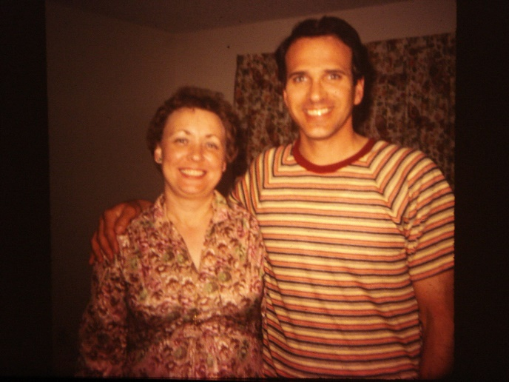We had many **friends in the Lehi 3rd ward**, but our closest friends were **Jim and Maryon Frazer**, and **Deloy and Lois Porter**. We grew to love these two couples very much. We did a lot with Maryon & Jim. We would eat at each other’s homes, or play games and visit. We would go to the temple together and we went to the BYU Education Week together and church education classes. They had a daughter, Malinda, who was a year younger than Shellie and a few years later, they adopted a daughter, Pam. Maryon & Jim later moved to Springville, Ohio. We visited them once and had an enjoyable time.

We’d go over to the Porters on Sunday evenings after church or they’d come to our home, and we’d play Rook and eat popcorn and other goodies, or we’d sing with Deloy as he played his guitar. Lois and I went shopping together and sewed together sometimes. I always picked up Lois to go to Relief Society. Lois and Ken gave me a surprise Birthday party at her home on the 28th of Dec. 1973. The Smiths, Cooleys, Porters and Ken & I were there. She made me a birthday cake and gave me a beautiful potted plant. We ate, played games, visited and had a good time. The Fraziers had other plans that they couldn’t get out of so they couldn’t be there. After a few years, Deloy & Lois divorced and they have both remarried. Lois is much happier now. Her & Her husband live in American Fork, Utah. She invited me to go to Woman’s Conference with her at BYU one year and stay with them overnight. I did and we enjoyed being together again.

Ken had been working for **Air Research** not quite a year when our wonderful friend, **Larry Braithwaite, asked Ken to work for him as the crew leader over the finish work in his construction business**. He made Ken such a good offer that we didn’t feel we could pass it up, plus Ken wasn’t happy at Air Research because he always wants to do a full day’s work for a full day’s pay and they didn’t have enough work for Ken to do. Ken also had a run-in with his boss, so he was glad to go, and his boss might have been glad to have him go. Ken made him look like a fool in front of others in a meeting as he had done that to Ken earlier. Ken was right, but if you want to keep your job, you don’t do that to your boss.

Ken loves to do carpentry work anyway, and Larry had made lots of money in his business and felt he could help us and Ken could help him, with this offer. Ken had been doing part-time work for Larry off and on before this time. Ken enjoyed the construction business and all went well until again the bottom dropped out of the building industry again, at least here in Arizona. Interest rates went sky high and building materials and lumber again went out of sight. Larry’s work cut down until he had to lay off all his men except Ken and his other three crew leaders. At this point, we were wondering what to do. Whether Ken should try again to go back into Data Processing, or to try and get his own license as a finish carpenter and go out on his own. Then, we felt an answer to prayer. John Howard, Ken’s former boss at Commercial Security Bank, called and asked if Ken would be willing to come back to work as a supervisor over the data processing department on the graveyard shift. He said if we had any problem selling our home (since he wanted Ken to start in two weeks) that the bank would help us. They would pay our way to move, etc. Ken had been called as a stake missionary, which he had always wanted to do, and was enjoying this very much, and we loved our new home - so this was a hard decision to make. But, we missed the association with our families, we missed the mountains, Ken missed the Utah hunting and fishing - so after praying, talking to the mission president and our Bishop, we decided to make the move.

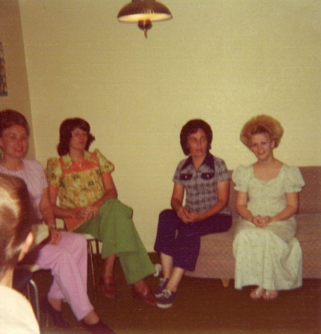 **Before we moved, Lois and Maryon gave Ken and I a surprise farewell open house at our home the Sunday night after Sacrament meeting.** They invited all the ward members and many helped them make cookies and they made punch and had a nice guest book for all of them to sign for us. It was really a surprise. We were relaxing after meeting when the Fraziers and Porters came and started making punch, etc., and soon the ward members began coming. It was really fun. Many came, and we were really touched by such thoughtfulness and wonderful friends. (Maryon is in pink in the picture and Lois is in blue.)

We went to the temple regularly with the Fraziers and then we’d eat out after or at least get a Sunday. We also talked them into going to Education Week with us, and they were really thrilled, as were we. They’d invite us to their home to eat occasionally or to come visit and eat snacks. We’d invite them also. We shared a garden with them at their place since they had two acres. We invited the Fraziers and Caldwells to our home for Christmas dinner. They helped bring food. We had a wonderful day.